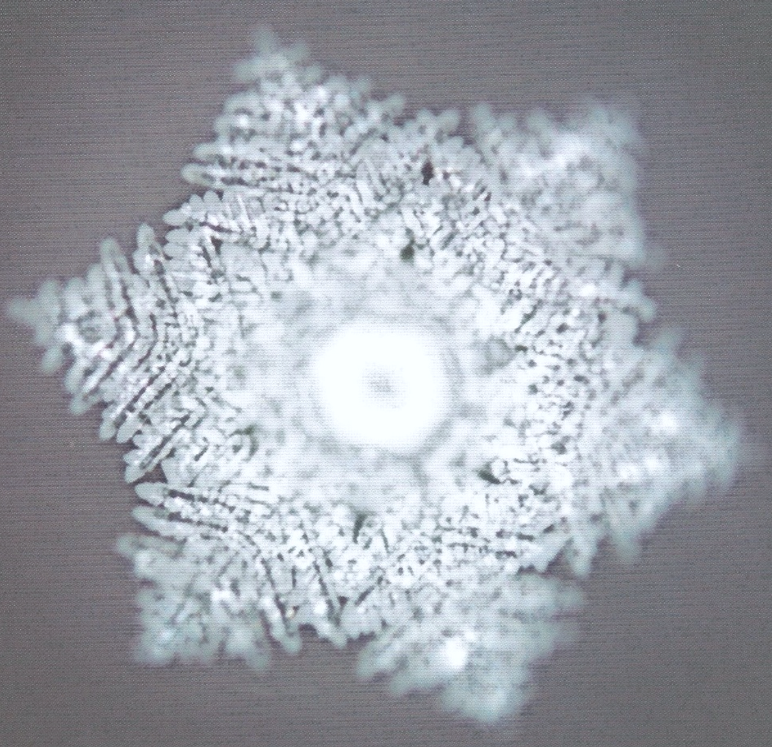
JNANA
Gnosis
KARMA
Duty
MANTRA
Sound
HATHA
Discipline Body
RAJA
Discipline Mind
BHAKTI
Service

